 **Assignment No : 05**

**Spring 2023**

**CSE—Data Communication And Networking**

Submitted by

**Name: Maaz Habib**

**Registration No.20PWCSE1952**

Class Section: **C**

“On my honor, as student of University of Engineering and Technology, I have neither given nor received unauthorized assistance on this academic work.”

Submitted to:

**Sir Ihsan-Ul-haq**

**Department of Computer Systems Engineering**

**University of Engineering and Technology, Peshawar**

**Task 1**

1. What is the key term for devices that are connected together?

**Ans: Network**

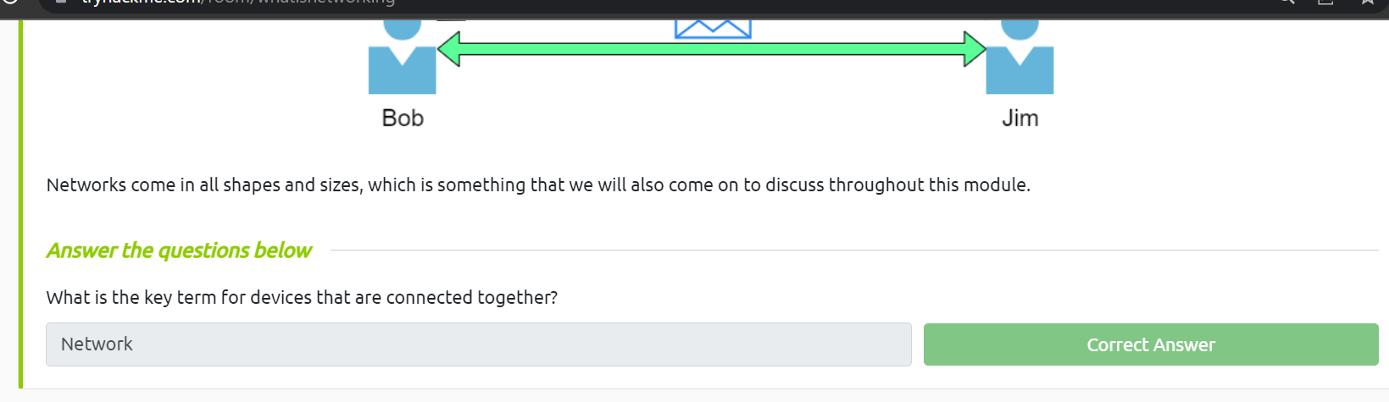

**Task 2**

1. 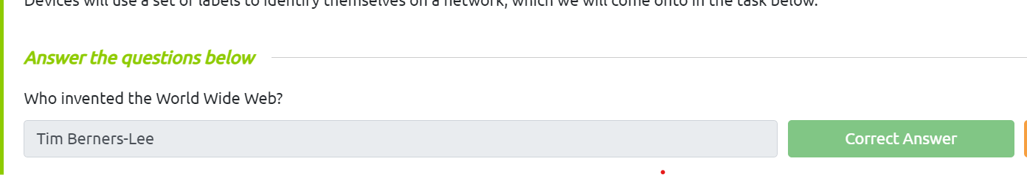Who invented the World Wide Web?

**Ans: Tim Berners-Lee**

**Task 3**

1. What does the term "IP" stand for?

**Ans: Internet Protocol**

1. What is each section of an IP address called?

**Ans : Octet**

1. How many sections (in digits) does an IP address have?

**Ans: 4**

1. What does the term "MAC" stand for?

**Ans : Media Access Control**

vii. Deploy the interactive lab using the "View Site" button and spoof your MAC address to access

the site. What is the flag?

Ans: **THM{YOU_GOT_ON_TRYHACKME}**

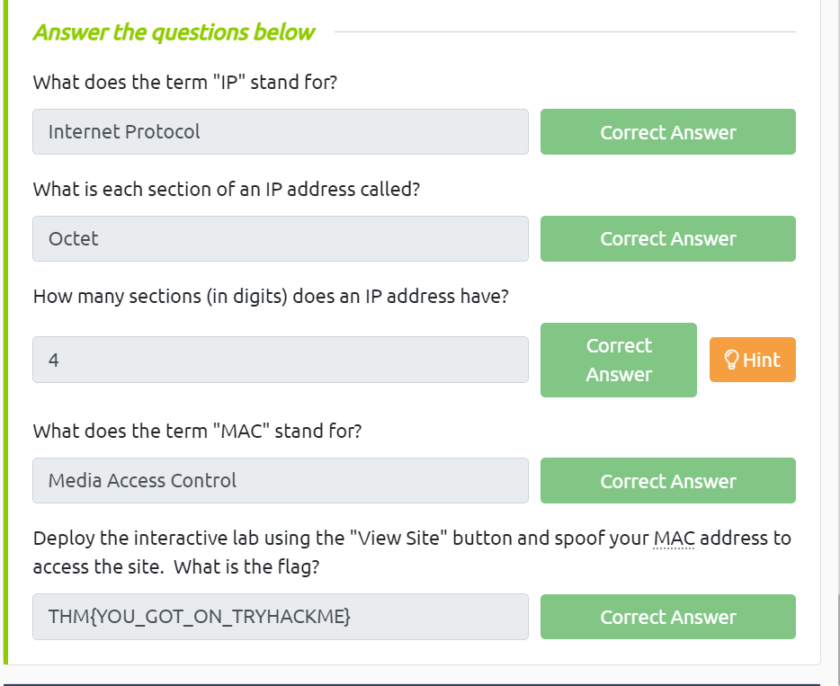

Task 4

1. What protocol does ping use?

**Ans: ICMP**

1. What is the syntax to ping 10.10.10.10?

**Ans: ping 10.10.10.10**

1. What flag do you get when you ping 8.8.8.8?

**Ans:THM{I_PINGED_THE_SERVER}**

